 Food Recommendation System

***Wireframe Documentation***

Homepage

We have divided Food Recommender System’s Homepage into Two Sections: -

1. First thing anyone will see is a pop-up window on Homepage which will ask for User Inputs like whether he/she wants Food Recommendations for what purpose.

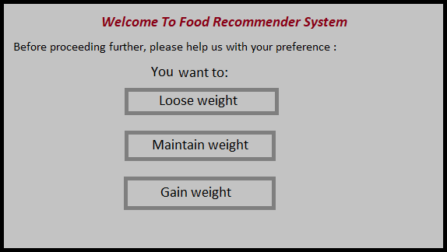

1. The User will encounter with another pop-up window asking for User details.

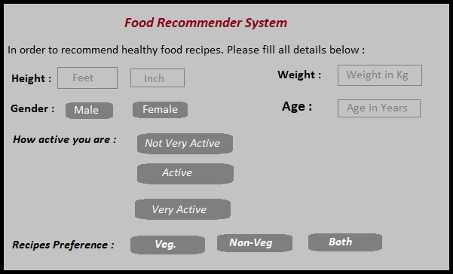

Based on User’s input, our Food Recommendation System will recommend recipes to User on Homepage itself. A sample view of Homepage showing results is below:

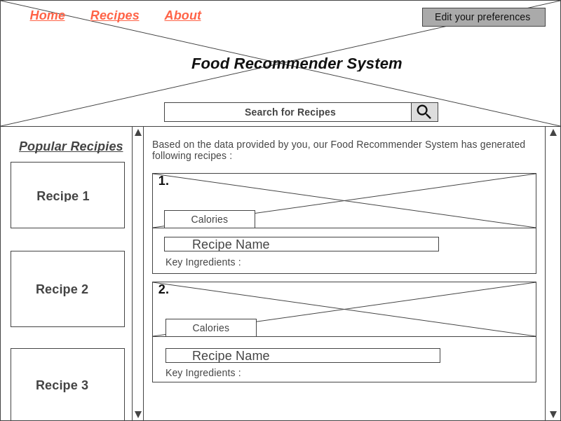

The **Crossed Sections** in above sample can be used for images of food & health tips quotation as background to give user a good experience.

# About Page

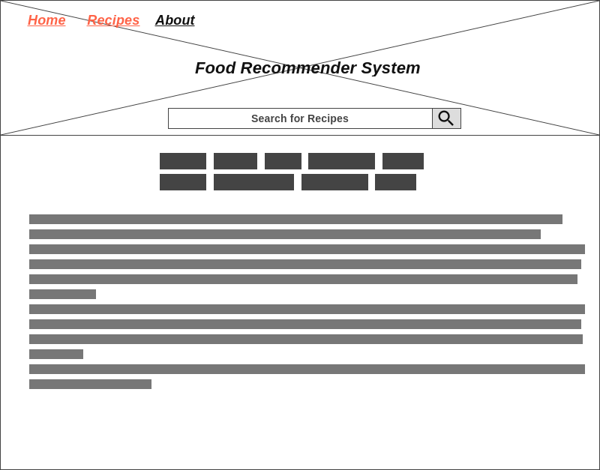

In this Sample, we have given space for Heading & for Texts.

# Variety of Recipes Page

In this Page, we will showcase some Best Recipes of each category for Users to see.

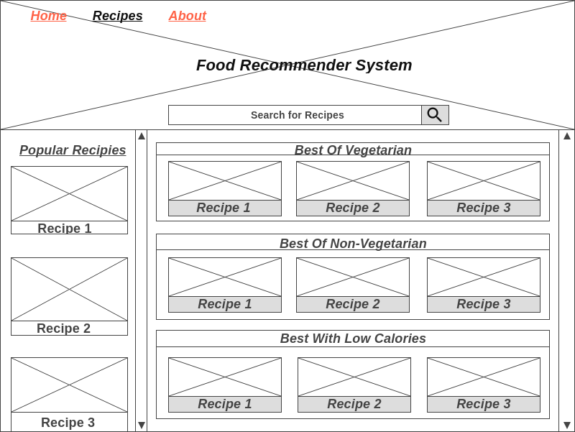

# Detailed Recipe Page

This will be the page where Recipe will be showcased with full details like the process of making it, amount of calories in it & list of ingredients to prepare it.

